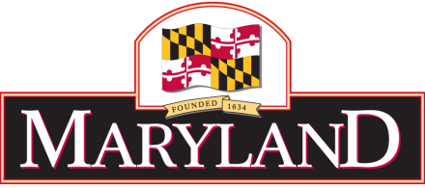

MARINE CONTRACTORS LICENSING BOARD
c/o Maryland Department of the Environment
1800 Washington Blvd., Suite 430, Baltimore, MD 21230
(800) 633-6101, ext. 3249
MARINE CONTRACTORS LICENSING BOARD
Meeting Minutes –August 9, 2021

Location: Virtual Meeting via Google Meet

BOARD MEMBERS PRESENT  Milton Rehbein, Chairman | OTHERS PRESENT  Matthew Standeven, Board Counsel
Tammy Roberson, MDE Rep
Josh Schleupner, Shore Contractor Rep
Douglas Suess, At Large Representative

CALL TO ORDER
The meeting was called to order by Mr. Rehbien at 10:05 am using the virtual platform Google Meet. Four Board members were present, as well as the Board’s legal counsel.

AGENDA REVIEW
The Board reviewed and approved the Board’s agenda.

REVIEW OF PRIOR MEETING MINUTES
The Board Chairman to send out the February meeting notes.

OLD BUSINESS

- Check on next training session with MES
- Chesapeake Turf – after a hold from Matt Standaven, Chesapeake Turf can complete and resubmit application
- MDE has hired a retired waste water employee to fulfil the vacant board administrator part time position
- Board – okayed to place MCLB Number on web site
- Board okayed to place minimum qualifications on the web site
- Board has no legislation for next session
- Board of Public Works wetland regulations became effective on June 28th 2021

NEW BUSINESS

- Motion to provide new administrator with a new laptop paid out of MCLB funds
Motion by Josh Schleupner seconded by Doug Suess
- Board decided to remove Board members names from the letterhead
- Monthly testing has not resumed at MDE Montgomery Park. All testing is still electronic
- Draft regulations to include white paper with definitions of tier license and minimum requirements

ADJOURNMENT
Motion to adjourn by Douglas Suess and seconded by Josh Schleupner. The Board voted and approved adjournment at 11:09 AM.

